Practical No.2
AIM: Study and implementation of different types of constraints.
Create the tables described below
Implementation :
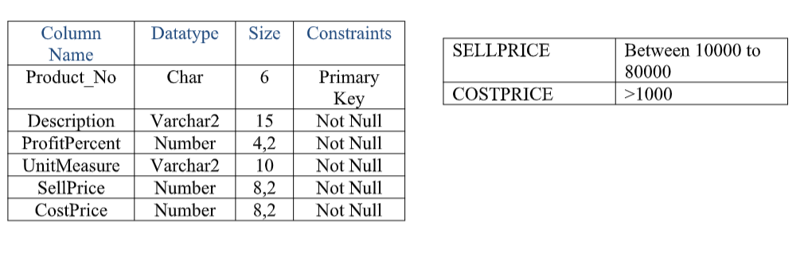
- PRODUCT_MASTER
- create table Product_Master (Product_No char(6) Constraints pk Primary Key,
Description Varchar2 (15) Constraints DES Not Null ,
ProfitPercent Number (4,2) Constraints PP Not Null,
UnitMeasure Varchar2 (10) Constraints UM Not Null,
SellPrice Number (8,2)Constraints SP Not Null,
CostPrice Number (8,2) Constraints CP Not Null);
desc Product_Master;
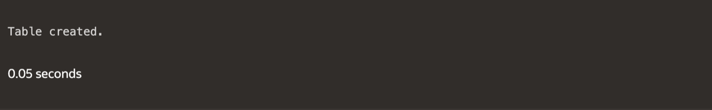
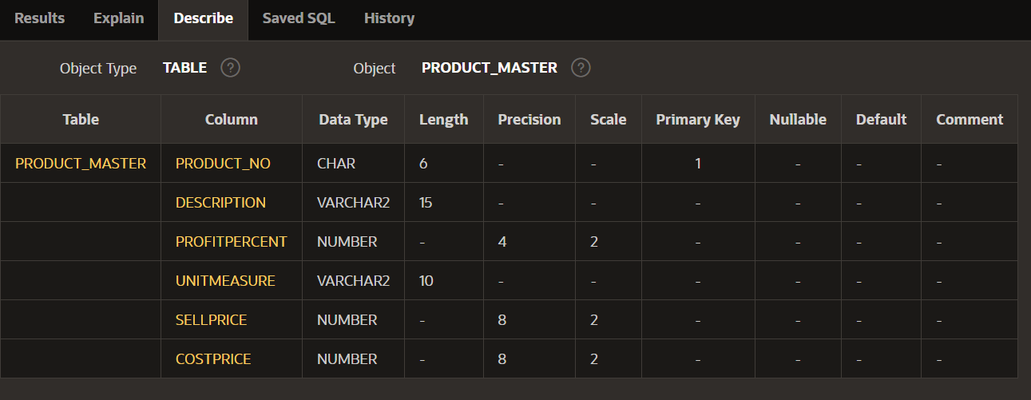

- alter table Product_Master
add constraint cpc Check(CostPrice > 1000);
add constraint srp Check(SellPrice < 1000 and SellPrice>8000)
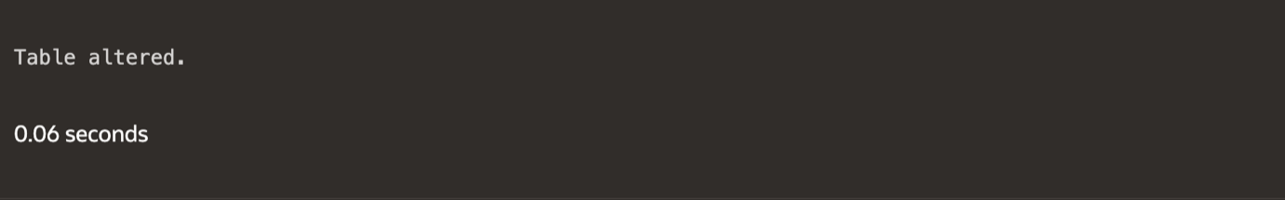

- SALESMAN_MASTER
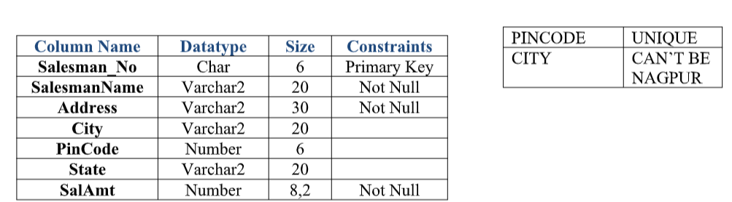
- create table Sales_Master (Salesman_No Char (6) Constraints SM Primary Key,
SalesmanName Varchar2 (20) Constraints SMN Not Null,
Address Varchar2 (30) Constraints Addre Not Null,
City Varchar2 (20),
PinCode Number (6),
State Varchar2 (20),
SalAmt Number (8,2) Constraints SA Not Null);

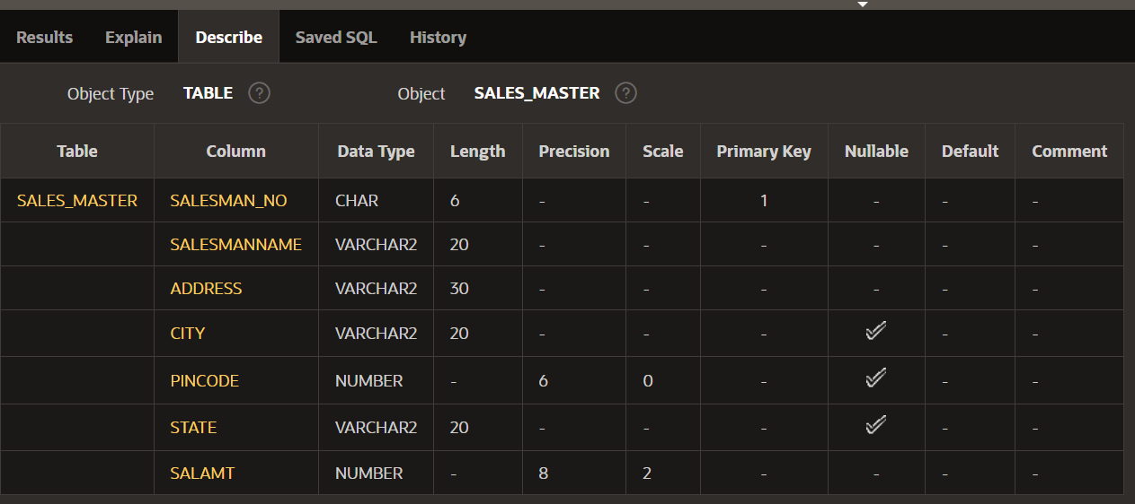
- alter table Sales_Master
add constraint pin_c_uni unique (PINCODE);
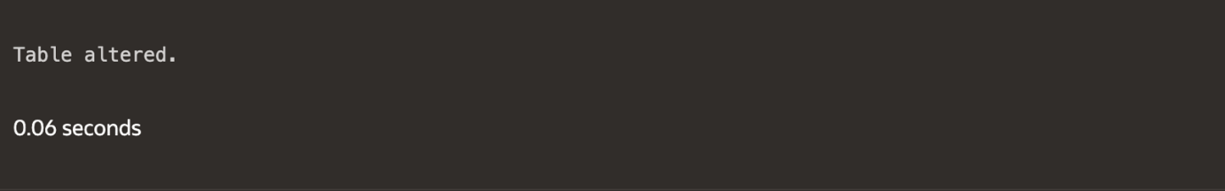

- Client_Master
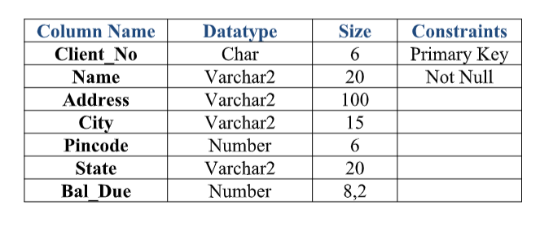
create table Client_Master (Client_No Char (6) Constraints CN Primary Key,
Name Varchar2 (20) Constraints N Not Null,
Address Varchar2 (100),
City Varchar2 (15),
Pincode Number (6),
State Varchar2 (20),
Bal_Due Number (8,2) );
desc Client_Master

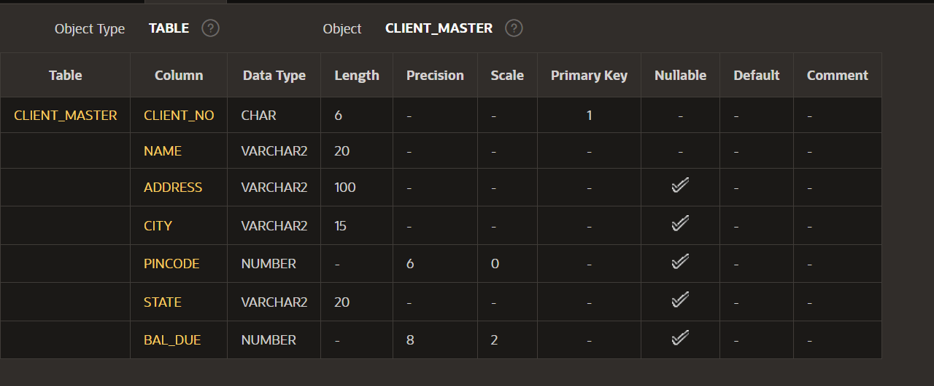

- Sales_Order
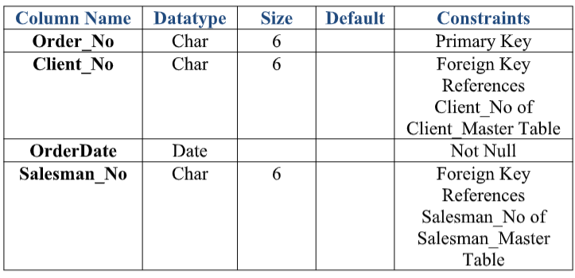
create table Sales_Order (Order_No Char (6) Constraints orn Primary Key,
Client_No Char (6) Constraints clien References Client_Master (Client_No),
OrderDate Date Constraints orda Not Null,
Salesman_No Char (6) Constraints S_SNOC References Sales_Master (Salesman_No ));

desc Sales_Order

